Time to Register & Donate!

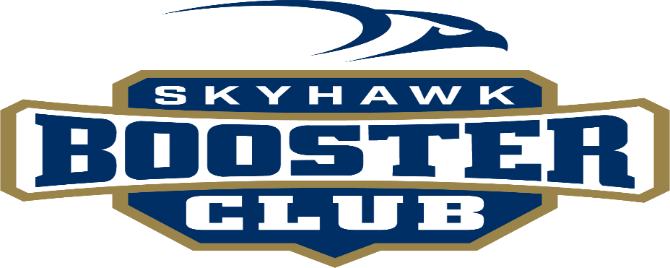

1st Annual Golf Tournament
June 24th, 2024 @ Apple Creek Country Club

The Skyhawk Booster club invites you to the 1st Annual Golf Tournament to be held at the Apple Creek Country Club on June 24th, 2024. This event is a great opportunity to help support Shiloh in all its extracurricular activities. The Booster Club is set in place to not only help with all of Shiloh’s athletic programs, but also support all the school’s programs and groups that are in need of additional financial support.
You are invited to play in the tournament or just attend the dinner and evening events. We also welcome you to join us as an event sponsor. If you would like to register, please fill out the attached Registration Form. This is a great opportunity to meet some fantastic people who are affiliated with Shiloh, past and present.
• Registration deadline is June 10th, 2024
• Four Person Scramble - $150 per person – includes Golf, Cart, and Steak Dinner.
• Limited to 36/ea 4 Man Teams. First come first serve.
Sponsorship Levels:
$2000 Level $1000 Level $800 Level
• Hole Sponsor, Company Name at Hole • Hole Sponsor, Company Name at Hole • Hole Sponsor, Company Name at Hole
• Company Name at evening event • Company Name at Evening Event • Includes golf up to 1 team of 4
• Includes golf up to 1 team of 4 • Includes golf up to 1 team of 4
• Includes $ in for all games at Registration Table.
• Includes Booster Club Swag

$500 Level $200 Level Donation & Door Prizes
• Hole Sponsor, Company Name at Hole • Hole Sponsor, Company Name at Hole
• Company name at evening event
• Dinner at the Event for 2

Registration

- Registration is very easy. Simply go to www.Shilohchristianboostergolf.com Pick your sponsorship level and sign up your team.
- Credit Card payment online
- Mail Checks & Paper registration form to Shiloh Booster Club 1915 Shiloh Drive. Bismarck, ND 58503 Checks can be written to “Shiloh Booster Club.”
- We can also invoice your business. If you would like that option, please send request to rocky@mbmaterials.com

If you chose to be a Hole sponsor, please send your company logo to rocky@mbmaterials.com

Sponsor Name: ___________________________________________________________

Contact Person:___________________________________________________________

Daytime Phone: __________________________________________________________

Mailing Address:__________________________________________________________

Email:___________________________________________________________________

*Please List names of Golfers if your sponsorship level includes a complimentary Team*

Golfer #1: _______________________________________________________________
Golfer #2:________________________________________________________________
Golfer #3:________________________________________________________________
Golfer #4:________________________________________________________________

Email: rocky@mbmaterials.com
Mail: Shiloh Booster Club, 1915 Shiloh Drive. Bismarck, ND 58506

